**SpongeBob Company Costume July 2025**

Costume parade will be **Tuesday** **July 8** Bring all costume pieces and shoes to rehearsal

Look up a fish from SpongeBob (TV show or broadway show) and make it neon. Do not choose a costume that might look like a lead role. You only have one costume!

Inspiration:

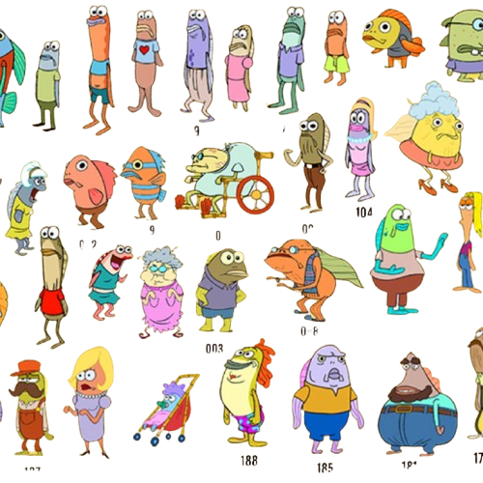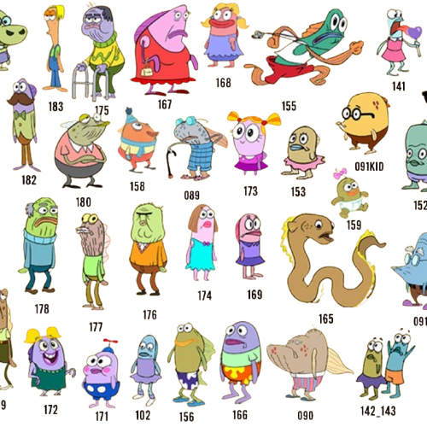

-Fun Pattern tropical shirts/pants/dresses

**Shoes:** tan or black jazz shoes, or character shoes (optional)

**-Skirt/ dress wearers need skin tone tights, need skin color leotard and black shorts for under shorter dress**

**-Button down shirt wearers need a white undershirt**

**Thrifting costume pieces will give a unique and less expensive look, try there before buying new!**

**Thrift Stores in the area…**

Liberty Thrift Stores (91 E Street Rd, Feasterville-Trevose, PA 19053)

Goodwill (10101 Bustleton Ave, Philadelphia, PA 19116)

Goodwill (2637 Street Rd. Bensalem, PA 19020)

Goodwill (2365 East Lincoln Hwy. Langhorne, PA 19047)

Salvation Army (191 Lincoln Hwy. Fairless Hills, PA 19030)

Goodwill (1487 West Street Rd. Warminster, PA 18974)

Liberty Thrift (979 Bethlehem Pike, Montgomeryville, PA 18936)

Second Avenue (163 Franklin Mills Blvd, Philadelphia, PA 19154)

Second Avenue (330 Commerce Blvd, Fairless Hills, PA 19030)

**Online dance stores:**

Discountdance.com

Dancewearsolutions.com

**Dance stores in the area:**

Little Dance Boutique (5827 Bristol Emilie Rd, Levittown, PA 19057)

Step Up Richboro Dancewear (881 Bustleton Pike, Richboro, PA 18954)

Arena Dance & Bodywear (NJ-33, Hamilton Township, NJ 08690)

**Other Online Options:**

Amazon